_________ beans ______________________
Collards & kale
BEETS

Mulch pile
----- arugula -----
scallions & lettuce seeds

Empty – was onions
carrots

Onions – Healthy Shares
And plot shares

_____________KALE SEEDS____ _______
Cukes – mostly pulled
Peppers, some tomatoes
tomatoes
tomatoes
_______SWISS CHARD SEEDLINGS________
chives
- - - - -
_____winter greens_____
tomatoes

Onions – Healthy Shares and plot shares
___ ----------------eggplant -----------------
----------swiss chard ----------------------

______________red mustard greens ____ -------corn---------
__________spinach seedlings __________ -------corn---------
misc squash & melon mounds
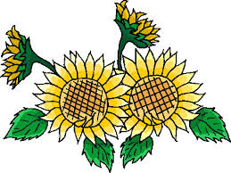 _______brussel sprouts ____________ red vine flowers

FLOWERS
DON’T PICK WINTER SQUASH YET ! !

Cabbage & sunflowers
Summer squash winter squash
VUF road
Cabbage & petunias
Broccoli & petunias

